**Recipe: Cherry Tomato Galette**

Lynne Char Bennett

Aug. 17, 2014

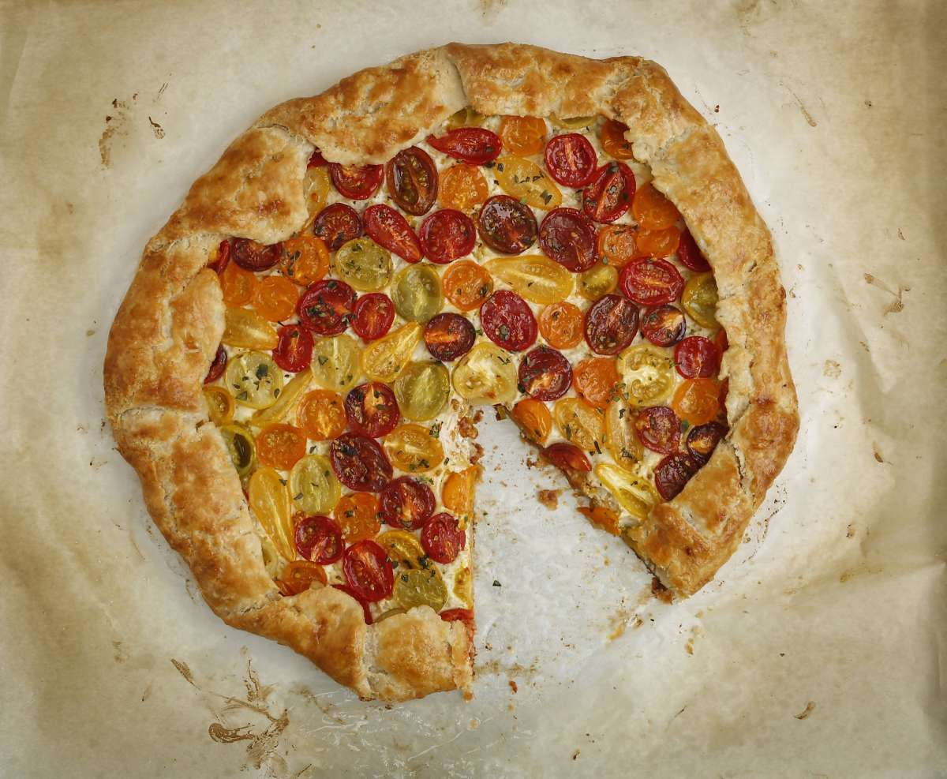

Cherry Tomato Galette Russell Yip/The Chronicle

Serves 10 to 12 as an appetizer

Warm, juicy cherry tomatoes star in this vegetarian dish, larger portions of which can serve as a light supper when served with a green salad. The crust is adapted from "Vegetarian Cooking for Everyone," by Deborah Madison.

Crust

1 cup all-purpose flour + more for dusting

1 cup pastry flour (or use an additional cup of all-purpose)

1 tablespoon sugar

½ teaspoon kosher salt

12 tablespoons (1½ sticks) cold unsalted butter cut into ½-inch pieces

1/3 to ½ cup ice water

Filling

1 large leek

2 to 3 tablespoons olive oil

½ teaspoon finely minced garlic

1 cup (8 ounces) ricotta

1½ tablespoons finely grated Parmigiano-Reggiano

3/8 teaspoon kosher salt, to taste

¼ teaspoon freshly ground black pepper, or to taste

1 large egg, well beaten

1¼ pound assorted cherry tomatoes, about 1½ pints, halved lengthwise

Extra virgin olive oil to finish

¼ to ½ teaspoon chopped marjoram, to taste

Fleur de sel or Maldon salt

For the crust: Combine the flours, sugar and salt in a medium bowl. Use a pastry blender or two knives to cut in the butter until you have some pea-size pieces left. Sprinkle the ice water over the top a tablespoon at a time and toss it with the flour mixture until you can gather the dough together into a ball. Use plastic wrap to help gather it up into a disk shape and enclose in plastic wrap. Refrigerate at least 30 minutes and up to a day. The dough can also be wrapped well and frozen for up to two months. Defrost in the refrigerator, then leave on the counter to get to cool room temperature so you can roll it.

For the filling: Trim off the root and the dark green leaves of the leek. Halve the white and light green portion lengthwise, rinse thoroughly and slice thinly crosswise.

Add the oil to a medium skillet over medium heat and add the leek. Cook for 1-2 minutes, stirring occasionally; add ¼ cup water, bring to a low simmer and cover. Steam, stirring occasionally, until tender and the volume has shrunk, about 10 minutes. Uncover and allow water to evaporate. Add the garlic and cook until aromatic. Turn the mixture into a medium bowl and cool. You should have about ½ cup.

Thoroughly mix in the ricotta, Parmigiano-Reggiano, salt, pepper and all but 1 tablespoon of the egg, which should be set aside.

To assemble: Have ready a parchment-lined rimless cookie sheet. Move the rack to the bottom third of the oven and preheat the oven to 400°.

Dust the work surface lightly with flour and roll the dough into a 14-inch circle; it doesn't need to be even. Move it to the prepared cookie sheet.

Spread a circle of the ricotta mixture over the dough, leaving a 2-inch border. Arrange the tomatoes cut side up, gently pressing them into the filling. Sprinkle the tomatoes lightly with salt. Fold the border of the dough up over the tomatoes, making pleats as needed, then brush the crust with the reserved egg.

Bake until the crust is golden brown, about 35 minutes. Drizzle the galette with extra virgin olive oil, sprinkle with marjoram and fleur de sel. Best served while still warm.